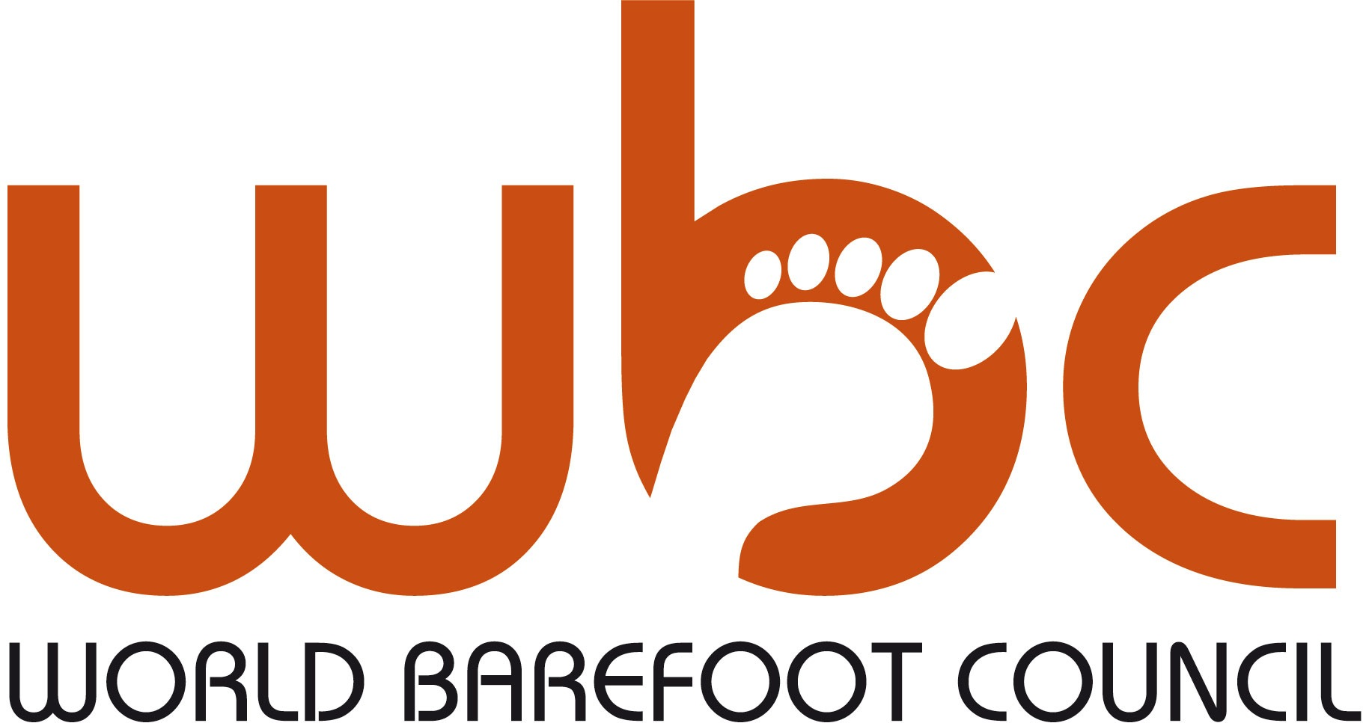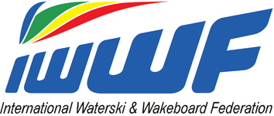
2014 World Barefoot Water Ski Championships
March 11-16th
Mulwala, NSW, Australian
DEFINITIVE ENTRY FORM

TO BE COMPLETED FOR EACH SKIER ENTERED. PLEASE USE BLOCK CAPITALS TO COMPLETE FORM

Return the forms to the Secretary of the Organizing Committee, your Confederation Barefoot Council Chairman, and the WBC Chairman
at least 4 weeks prior to the start of competition. Deadline: 11/feb/14

LOC: skiproshop@me.com
WBC Chairman: Richard Gray g1footer@aol.com

ENTERING AS | SLALOM | TRICKS | JUMP
 | JR / SR / Open | JR / SR / Open | JR / SR / Open
Team Member in:
Reserve Team Member in:
Individually Qualified skier in:
FAMILY NAME | FIRST NAME | SEX | DATE OF BIRTH
SKIER'S FEDERATION:
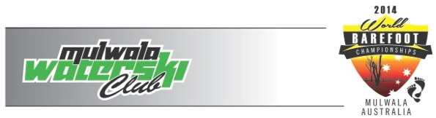
Any Federation not meeting these requirements will not be allowed to compete until the Federation pays to the WBC a fine of $10 (USD) per skier per day after the four week
deadline, for each skier not officially entered.

Doping control
In accordance with the IWWF Anti-Doping Rules, drug controls will be conducted during this competition. In entering this competition all riders agree to be subject to doping control. Information about the IWWF Anti-Doping programme can be found at: http://www.iwsf.com/AntiDoping/2013%20WEBpageinformation.htm where there are also links to the list of banned substances.

