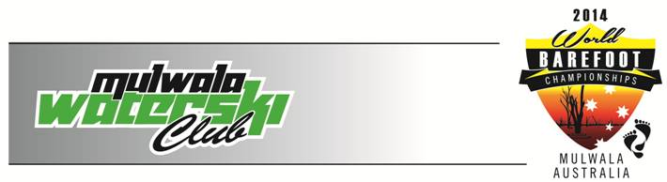
March 11 - 16, 2014
Mulwala, Australia
INTENTION TO COMPETE

We intend to enter the following team and/or individual skiers to the above World Barefoot Championships:

FEDERATION:
DIVISION | OPEN |  | JUNIOR |  | SENIOR
Team Skiers | MALE | FEMALE | MALE | FEMALE | MALE | FEMALE
SLALOM
TRICKS
JUMP
Independent Skiers | MALE | FEMALE | MALE | FEMALE | MALE | FEMALE
SLALOM
TRICKS
JUMP

Contact Person: email:

Please return this form as soon as possible or prior to the deadline of January 13, 2014 to the following people:

Local Organizing Committee skiproshop@me.com
Richard Gray – Chairman WBC g1footer@aol.com

Any Federation not meeting this requirement shall not be allowed to compete until they pay a fine of $200 (USD) to the World Barefoot Council.

Doping control
In accordance with the IWWF Anti-Doping Rules, drug controls will be conducted during this competition. In entering this competition all Athletes agree to be subject to doping control. Information about the IWWF Anti-Doping programme can be found at: http://www.iwsf.com/AntiDoping/WEBpageinformation10.htm where there are also links to the list of banned substances.
